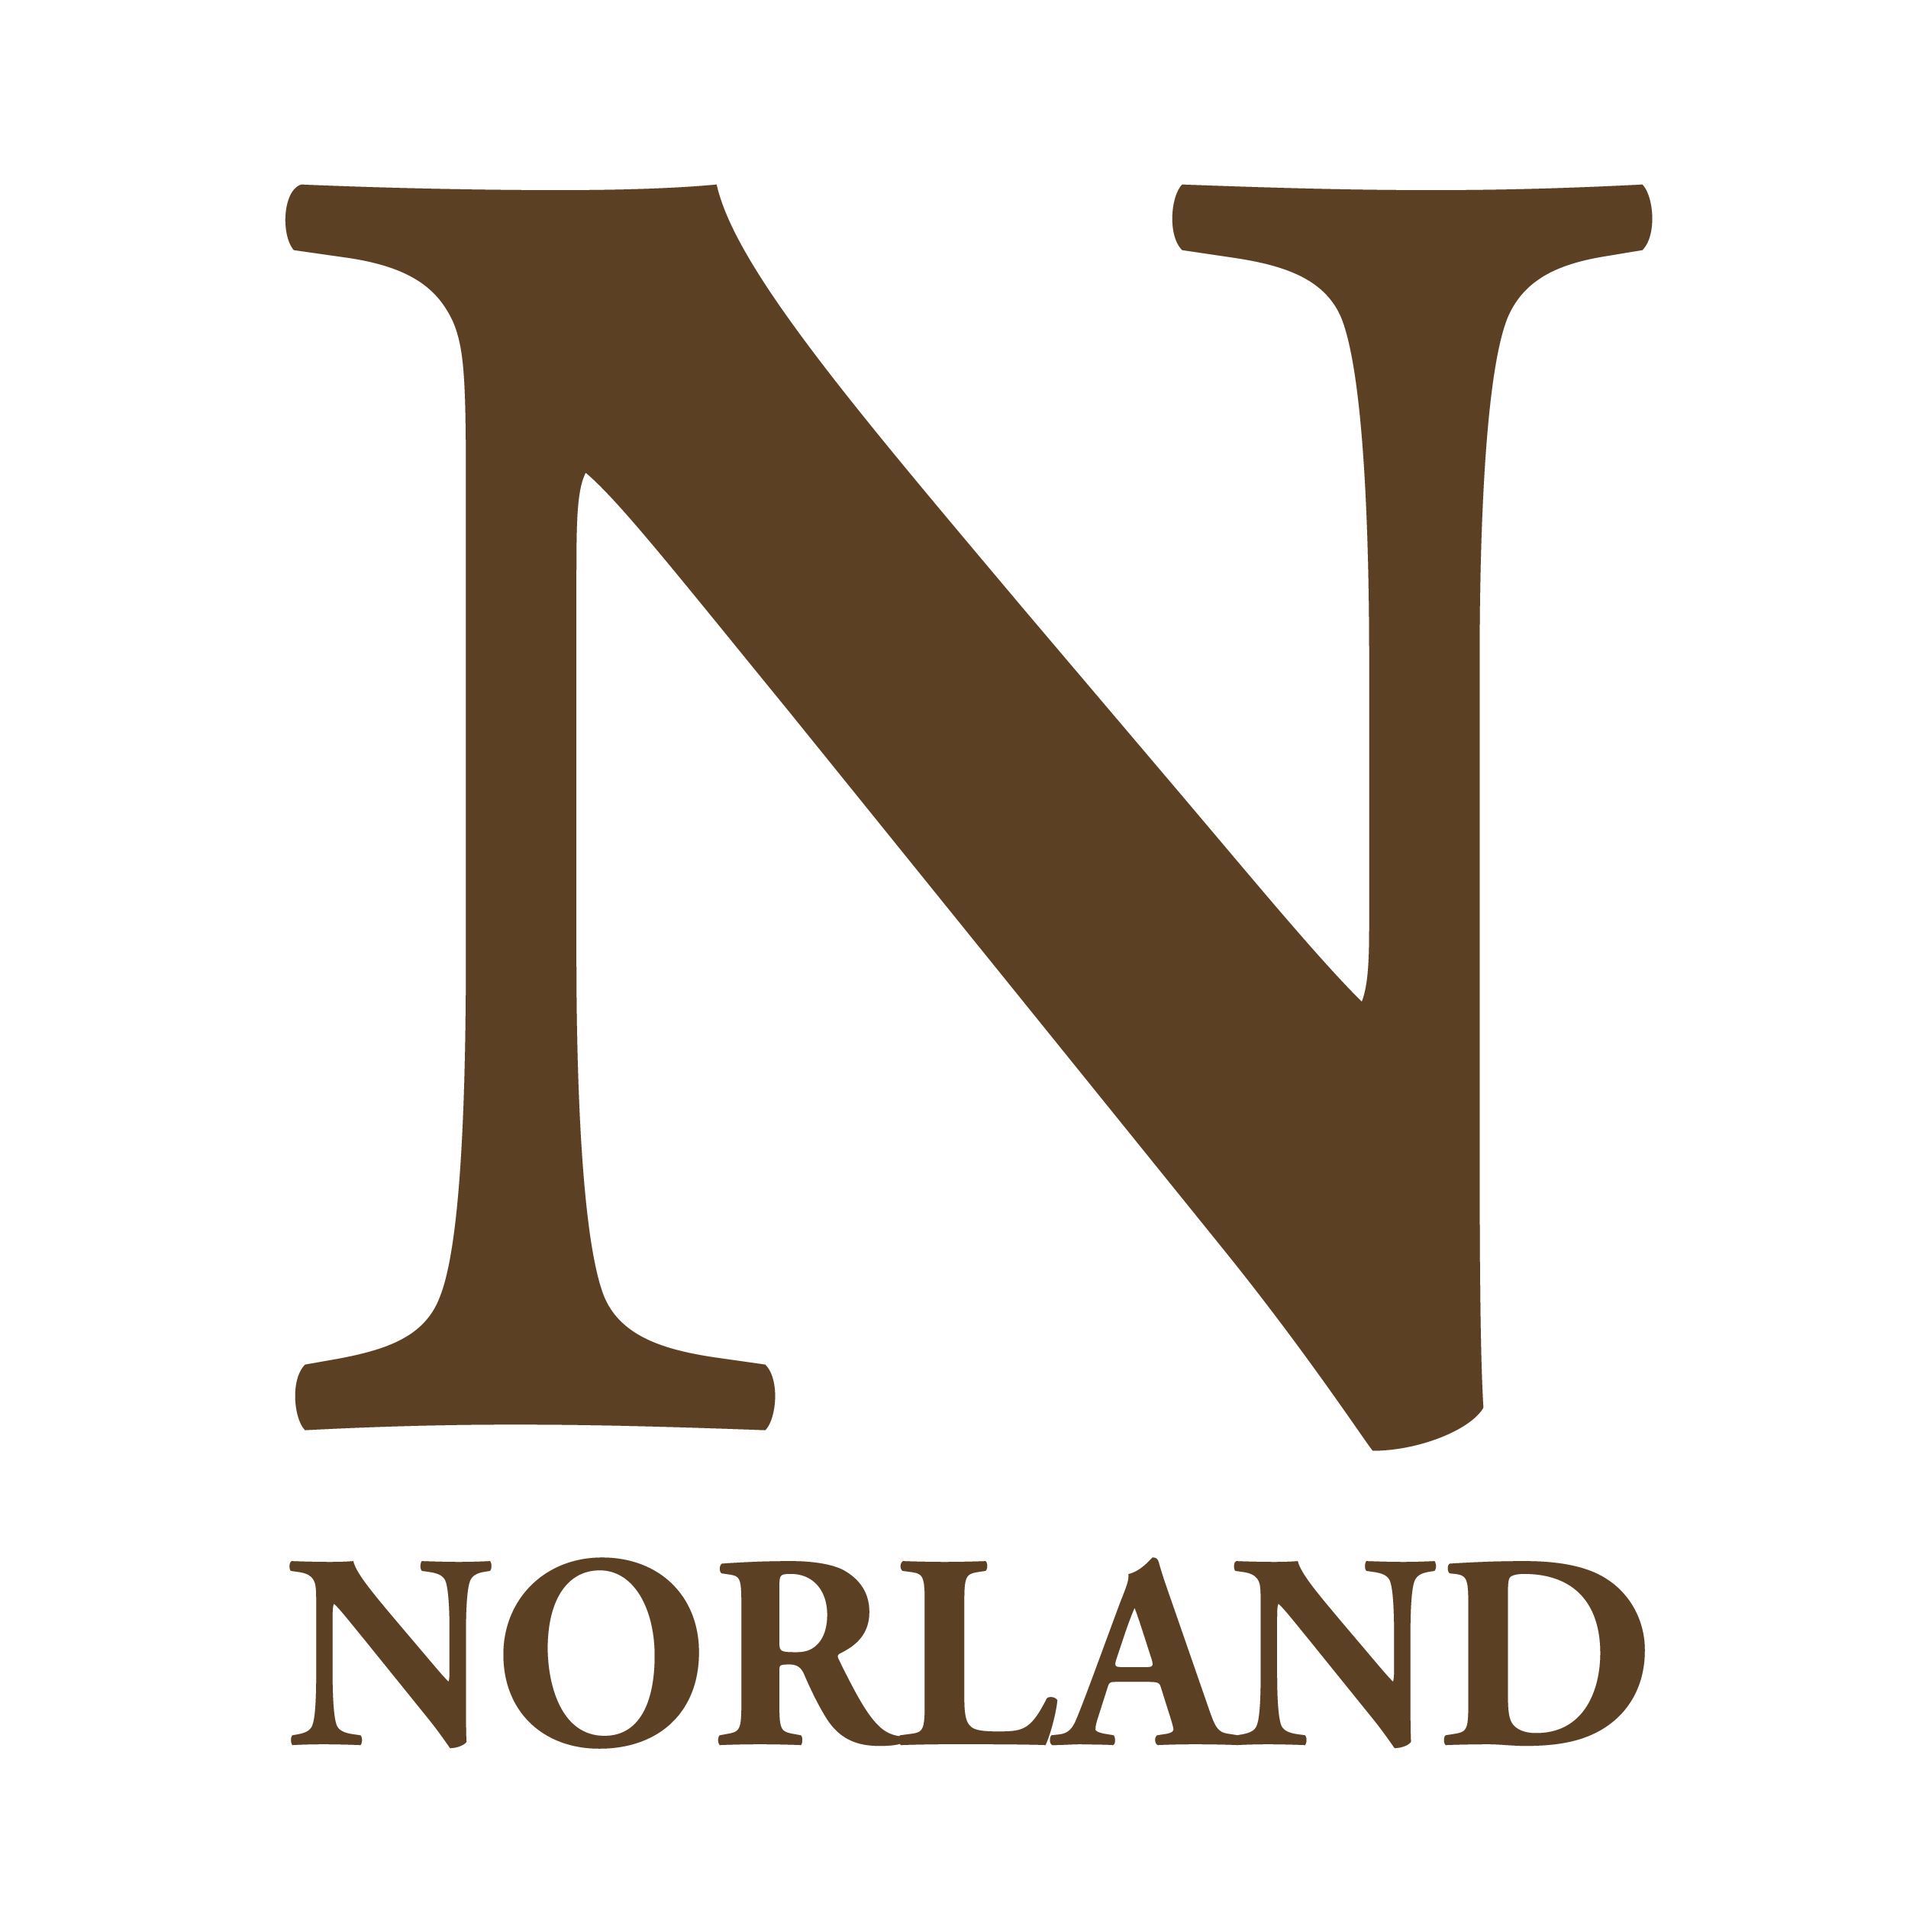
TERMS AND CONDITIONS
Bank Lecturer in Early Years
Ad hoc hours

Conditions of service
Full details of conditions of employment will be set out in a Limited Duration Engagement Scheme contract.

Offers of employment
Norland is committed to safeguarding and ensuring the welfare of children, young people and vulnerable adults. We expect all students and staff to share this commitment.

The suitability of all prospective staff will be assessed during the recruitment process in line with this commitment. All offers made will be on the condition of relevant safer recruitment checks being conducted and in line with the college policies and procedures.

This offer of employment is subject to proven eligibility to work in the UK, satisfactory clearance from the Disclosure and Barring Service (DBS), verified references and qualifications.

Remuneration
£29 per hour
Salaries are paid on the last Friday of each month comprising the salary for the whole month.

Working hours

This is a bank position where the hours are ad hoc. Work will be offered as and when required. You may accept or decline this work at your complete discretion.

The successful candidate will also be expected to work flexibly according to the needs of Norland.

Annual leave

The holiday year runs between 1 September and 31 August. As the hours for this post fall within
term time, it is impractical to provide your holiday entitlement in the normal way. In
accordance with the published advice of ACAS, holiday entitlement is therefore calculated and
paid in respect of each month worked.

The normal full time annual leave provision is 7.6 weeks which equates to 38 working days (including 8 Public Bank Holidays).

Pension scheme
The post holder will be entitled to participate in the Department for Education and Employment Teachers Pension Scheme under the Teachers Superannuation (Consolidation) Regulations 1988 as amended from time to time.

Flexibility
As a condition of employment, the post holder may be required to undertake such other duties as may reasonably be required, in addition to the major tasks outlined in the job description.

Smoking and vaping policy
Norland operates a strict no smoking or vaping policy.

Academic freedom
The governing body is responsible for ensuring that freedom of speech operates throughout Norland, and that staff shall have freedom within the law to question and test received wisdom, and to put forward new ideas and controversial or unpopular opinions, without placing themselves in jeopardy or losing their jobs or any privileges they may have at Norland.

Equal opportunities
Norland is committed to the promotion of equal opportunities and is dedicated to pursuing non-discriminatory policies and practices and to eliminate unfair discrimination on any basis. This means that we are striving to ensure that no job applicant will receive less favourable treatment than another on grounds of gender, marital status, racial origin, disability, sexual orientation or political or religious beliefs.

